VCL Rich Edit Control

Word® Inspired Rich Text Editor

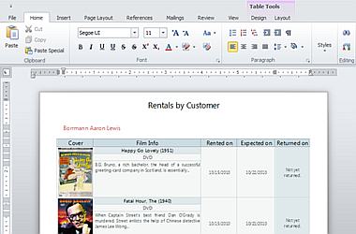

The DevExpress VCL Rich Edit Control allows you to introduce advanced text editing capabilities into your next application with ease. The Rich Edit Control provides comprehensive text formatting options, mail-merge and a rich collection of end-user options so you can deliver your best, without limits or compromise.
To the Top

